CDAR2_IG_QRDA_R1_N1_2021MAY



HL7 CDA® R2 Implementation Guide: Quality

Reporting Document Architecture (QRDA III),

Release 1 – US Realm

Volume 2

MAY 2021

**HL7 Normative Release 1**

**Sponsored by:  
Clinical Quality Information Work Group**

Copyright © 2020 Health Level Seven International ® ALL RIGHTS RESERVED. The reproduction of this material in any form is strictly forbidden without the written permission of the publisher. HL7 and Health Level Seven are registered trademarks of Health Level Seven International. Reg. U.S. Pat & TM Off**.**

Use of this material is governed by HL7's [**IP Compliance Policy**](http://www.hl7.org/legal/ippolicy.cfm?ref=nav).

**IMPORTANT NOTES:**

HL7 licenses its standards and select IP free of charge. **If you did not acquire a free license from HL7 for this document,** you are not authorized to access or make any use of it. To obtain a free license, please visit http://www.HL7.org/implement/standards/index.cfm.

**If you are the individual that obtained the license for this HL7 Standard, specification or other freely licensed work (in each and every instance "Specified Material")**, the following describes the permitted uses of the Material.

**A. HL7 INDIVIDUAL, STUDENT AND HEALTH PROFESSIONAL MEMBERS,** who register and agree to the terms of HL7’s license, are authorized, without additional charge, to read, and to use Specified Material to develop and sell products and services that implement, but do not directly incorporate, the Specified Material in whole or in part without paying license fees to HL7.

INDIVIDUAL, STUDENT AND HEALTH PROFESSIONAL MEMBERS wishing to incorporate additional items of Special Material in whole or part, into products and services, or to enjoy additional authorizations granted to HL7 ORGANIZATIONAL MEMBERS as noted below, must become ORGANIZATIONAL MEMBERS of HL7.

**B. HL7 ORGANIZATION MEMBERS,** who register and agree to the terms of HL7's License, are authorized, without additional charge, on a perpetual (except as provided for in the full license terms governing the Material), non-exclusive and worldwide basis, the right to (a) download, copy (for internal purposes only) and share this Material with your employees and consultants for study purposes, and (b) utilize the Material for the purpose of developing, making, having made, using, marketing, importing, offering to sell or license, and selling or licensing, and to otherwise distribute, Compliant Products, in all cases subject to the conditions set forth in this Agreement and any relevant patent and other intellectual property rights of third parties (which may include members of HL7). No other license, sublicense, or other rights of any kind are granted under this Agreement.

**C. NON-MEMBERS,** who register and agree to the terms of HL7’s IP policy for Specified Material, are authorized, without additional charge, to read and use the Specified Material for evaluating whether to implement, or in implementing, the Specified Material, and to use Specified Material to develop and sell products and services that implement, but do not directly incorporate, the Specified Material in whole or in part.

NON-MEMBERS wishing to incorporate additional items of Specified Material in whole or part, into products and services, or to enjoy the additional authorizations granted to HL7 ORGANIZATIONAL MEMBERS, as noted above, must become ORGANIZATIONAL MEMBERS of HL7.

Please see http://www.HL7.org/legal/ippolicy.cfm for the full license terms governing the Material.

**Ownership. Licensee agrees and acknowledges that HL7 owns all right, title, and interest, in and to the Materials. Licensee shall take no action contrary to, or inconsistent with, the foregoing.**

**Licensee agrees and acknowledges that HL7 may not own all right, title, and interest, in and to the Materials and that the Materials may contain and/or reference intellectual property owned by third parties (“Third Party IP”). Acceptance of these License Terms does not grant Licensee any rights with respect to Third Party IP. Licensee alone is responsible for identifying and obtaining any necessary licenses or authorizations to utilize Third Party IP in connection with the Materials or otherwise. Any actions, claims or suits brought by a third party resulting from a breach of any Third Party IP right by the Licensee remains the Licensee’s liability.**

Following is a non-exhaustive list of third-party terminologies that may require a separate license:

| **Terminology** | **Owner/Contact** |
| --- | --- |
| Current Procedures Terminology (CPT) code set | American Medical Association https://www.ama-assn.org/practice-management/cpt-licensing |
| SNOMED CT | SNOMED International http://www.snomed.org/snomed-ct/get-snomed-ct or info@ihtsdo.org |
| Logical Observation Identifiers Names & Codes (LOINC) | Regenstrief Institute |
| International Classification of Diseases (ICD) codes | World Health Organization (WHO) |
| UCC Health Care Provider Taxonomy code set | American Medical Association. Please see www.nucc.org. AMA licensing contact: 312-464-5022 (AMA IP services) |

|  |  |
| --- | --- |
| Primary Editor  /Co-Chair: | Yan Heras, PhD  Optimum eHealth LLC  [yan.heras@optimumehealth.com](mailto:yan.heras@optimumehealth.com) |
| Co-Chair: | Floyd Eisenberg, MD iParsimony LLC [FEisenberg@iParsimony.com](mailto:FEisenberg@iParsimony.com) |
| Co-Chair: | Paul Denning  MITRE Corporation  [pauld@mitre.org](mailto:pauld@mitre.org) |
| Co-Chair: | Patty Craig The Joint Commission [pcraig@jointcommission.org](mailto:pcraig@jointcommission.org) |
| Co-Chair: | Juliet Rubini  Mathematica  [JRubini@mathematica-mpr.com](mailto:JRubini@mathematica-mpr.com) |
| Co-Editor: | Matthew Tiller  ESAC Inc  [matthew.tiller@esacinc.com](mailto:matthew.tiller@esacinc.com) |
| Co-Editor: | Dan Donahue  ESAC Inc  [dan.donahue@esacinc.com](mailto:dan.donahue@esacinc.com) |
| Co-Editor: | Stan Rankins  Telligen [srankins@telligen.org](mailto:srankins@telligen.org) |
| Co-Editors for the past release(s):  Gay Dolin: Namaste Informatics gdolin@namasteinformatics.com  Robert H. Dolin: bobdolin@gmail.com  Michael Holck: ESAC Inc. [Michael.holck@esacinc.com](mailto:Michael.holck@esacinc.com)  Sarah Gaunt: Lantana Consulting Group sarah.gaunt@lantanagroup.com  Patty Craig: The Joint Commission, [pcraig@jointcommission.org](mailto:pcraig@jointcommission.org)  Marc Hadley: MITRE Corportion, [mhadley@mitre.org](mailto:mhadley@mitre.org)  Lisa Nelson: [LisaRNelson@cox.net](mailto:LisaRNelson@cox.net)  Lauren Wood: [lauren@texuality.com](mailto:lauren@texuality.com)  Barry Robson: Quantal Semantics Inc. St Matthews University Florida and Grand Cayman robsonb@aol.com  Jonathan Landsman: jonathan.landsman@truvenhealth.com  Nagesh Bashyam (Dragon): Drajer LLC, nagesh.bashyam@drajer.com  Chris Bontempi, McKesson, chris.bontempi@mckesson.com  Rik Smithies: Nprogram Ltd, rik@nprogram.co.uk  Liora Alschuler: Lantana Consulting Group, liora.alschuler@lantanagroup.com | |

Acknowledgments

This guide was produced and developed through the joint efforts of Health Level Seven (HL7) and the Office of the National Coordinator (ONC) within the US Department of Health and Human Services (HSS).

The project was carried out within the ONC’s Standards and Interoperability (S&I) Framework, specifically within the Query Health Work Group, as the HL7 Clinical Document Architecture (CDA) Quality Reporting Document Architecture (QRDA) III Project for the US Realm. In addition to the Query Health technical experts and participants, the group included representatives from the Joint Commission, the National Quality Forum (NQF) and the Centers for Medicare and Medicaid Services (CMS). The project could not have been completed without their real-world experience.

This specification is a set of constraints on existing work, and the extent to which it can accommodate the expressive requirements of quality reporting over time is a function of the richness of the model on which it is built, the HL7 Reference Information Model (RIM) and the RIM document standard, and the Clinical Document Architecture Release 2 (CDA R2). We thank all those who have worked for over a decade to produce these fundamental specifications; we especially thank the HL7 Structured Documents Working Group for their support of this project.

This material contains content from SNOMED CT® (<http://www.ihtsdo.org/snomed-ct/>). SNOMED CT is a registered trademark of the International Health Terminology Standard Development Organization (IHTSDO).

This material contains content from LOINC® ([http://loinc.org](http://loinc.org/)). The LOINC table, LOINC codes, and LOINC panels and forms file are copyright © 1995-2020, Regenstrief Institute, Inc. and the Logical Observation Identifiers Names and Codes (LOINC) Committee. All are available at no cost under the license at <http://loinc.org/terms-of-use>.

Table of Contents

1 Introduction 8

1.1 Purpose 8

1.2 Audience 8

1.3 Approach 8

1.4 CDA R2 9

1.5 Background 9

1.5.1 QRDA Category I – Single Patient Report 9

1.5.2 QRDA Category II – Patient List Report 10

1.5.3 QRDA Category III – Calculated Report 10

1.6 Current Project 10

1.6.1 QRDA Category III Normative R1 10

1.6.2 Relationship to Health Quality Measures Format (HQMF) 11

1.6.3 Relationship to Clinical Quality Language (CQL) 12

1.7 Organization of This Guide 13

1.8 Conformance Conventions Used in This Guide 13

1.8.1 Templates and Conformance Statements 13

1.8.2 Template Versioning 15

1.8.3 Open and Closed Templates 15

1.8.4 Conformance Verbs (Keywords) 15

1.8.5 Cardinality 16

1.8.6 Vocabulary Conformance 17

1.8.7 Null Flavor 18

1.8.8 Data Types 19

1.9 XML Conventions Used in This Guide 20

1.9.1 XPath Notation 20

1.9.2 XML Examples and Sample Documents 20

1.10 Contents of the Package 21

2 QRDA Category III 22

2.1 Major Components of a QRDA Category III Document 22

2.2 Report Format 25

2.3 Organizational Roles 26

3 References 28

Appendix A — Acronyms and Abbreviations 29

Table of Figures

Figure 1: Quality reporting using HQMF and QRDA 12

Figure 2: Constraints Format Example 14

Figure 3: Constraints Format – Only One Allowed 16

Figure 4: Constraints Format – Only One Like This Allowed 17

Figure 5: Binding to a Single Code 17

Figure 6: XML Expression of a Single-code Binding 18

Figure 7: nullFlavor Example 18

Figure 8: Attribute Required (nullFlavor Not Allowed) 19

Figure 9: Allowed nullFlavors when element is required (with xml examples) 19

Figure 10: XML Document Example 20

Figure 11: XPath Expression Example 20

Figure 12: ClinicalDocument Example 21

Figure 13: Skeletal QRDA Category III Document 23

Figure 14: QRDA Rendering 24

Table of Tables

Table 1: Content of the Package 21

Table 2: Header Participant Scenarios 26

Table 3: Header Relationship Scenarios 27

# Introduction

"If you cannot measure it, you cannot improve it."

Lord Kelvin (1824-1907)

## Purpose

This document describes constraints on the Clinical Document Architecture Release 2 (CDA R2) header and body elements for Quality Reporting Document Architecture (QRDA) Category III documents. The Institute of Medicine (IOM) definition of quality is: “The degree to which health services for individuals and populations increase the likelihood of desired health outcomes and are consistent with current professional knowledge.”[1] For care quality to be evaluated, it must be standardized and communicated to the appropriate organizations.

QRDA Category III is a document format that provides a standard structure with which to report aggregated quality measure data to organizations that will analyze and interpret the data. Quality measurement in health care is complex. Accurate, interpretable data efficiently gathered and communicated is key in correctly assessing that quality care is delivered.

## Audience

The audience for this document includes software developers and implementers with reporting capabilities within their electronic health record (EHR) systems; developers and analysts in receiving institutions; and local, regional, and national health information exchange networks which wish to create and/or process CDA reporting documents created according to this specification.

## Approach

Overall, the approach taken here is consistent with balloted implementation guides (IGs) for CDA. These publications view the ultimate implementation specification as a series of layered constraints. CDA itself is a set of constraints on the Health Level Seven (HL7) Reference Information Model (RIM). Implementation guides such as this add constraints to CDA through conformance statements that further define and restrict the sequence and cardinality of CDA objects and the vocabulary sets for coded elements.

This implementation guide is the QRDA Category III Normative Release 1. The Background and Current Project sections describe the development of this normative IG.

## CDA R2

CDA R2 is “… a document markup standard that specifies the structure and semantics of ‘clinical documents’ for the purpose of exchange” [CDA R2, Section 1.1; see References]. Clinical documents, according to CDA, have six characteristics:

* Persistence
* Stewardship
* Potential for authentication
* Context
* Wholeness
* Human readability

CDA defines a header for classification and management and a document body that carries the clinical record. While the header metadata are prescriptive and designed for consistency across all instances, the body is highly generic, leaving the designation of semantic requirements to implementation guides such as this one.

## Background

In early pilots of the QRDA initiative, participating organizations confirmed the feasibility of using the HL7 Clinical Document Architecture (CDA) as the foundation for the QRDA specification. The participants concluded that CDA provided the technical underpinnings for communicating pediatric and adult quality measures for both inpatient and ambulatory care settings.

### QRDA Category I – Single Patient Report

A QRDA Category I report is an individual-patient-level quality report. Each report contains quality data for one patient for one or more quality measures, where the data elements in the report are defined by the particular measure(s) being reported on. A QRDA Category I report contains raw applicable patient data. When pooled and analyzed, each report contributes the quality data necessary to calculate population measure metrics.

QRDA Release 1 (R1) defined the CDA framework for quality reports and a method for referencing a quality measure. The Standard for Trial Use (STU) recommended the re-use of Consolidated Continuity of Care Document (C-CDA)[2] clinical statements where applicable to send measure data elements. Several QRDA I R1 STU releases have been published to align with the Quality Data Model (QDM) updates.[3],[4]

### QRDA Category II – Patient List Report

A QRDA Category II report is a multi-patient-level quality data report. Each report contains quality data for a set of patients for one or more quality measures, where the data elements in the report are defined by the particular measure(s) being reported on.

Whereas a QRDA Category I report contains only raw applicable patient data, a QRDA Category II report includes flags for each patient indicating whether the patient qualifies for a measure’s numerator, denominator, exclusion, or other aggregate data element. These qualifications can be pooled and counted to create the QRDA Category III report.

### QRDA Category III – Calculated Report

A QRDA Category III report is an aggregate quality report. Each report contains calculated summary data for one or more measures for a specified population of patients within a particular health system over a specific period of time. The QRDA Category III Draft Standard for Trial Use (DSTU) Release 1 was first published in November 2012.[5] An errata update to the QRDA Category III DSTU R1 was released in July 2014. QRDA Category III DSTU R1.1 was published in March 2016, which incorporated errata approved since July 2014. In December 2016, the Standard for Trial Use (STU) Release 2 was published to support the need of reporting for improvement activities[6] and promoting interoperability (formerly known as advancing care information) measures[7]. In June 2017, the STU Release 2.1 was published to allow performance period to be reported at each performance category level, e.g., measure, improvement activities, and promoting interoperability measures.

## Current Project

### QRDA Category III Normative R1

Since the publication of QRDA Category I R1 DSTU in 2012, the standard has experienced very rapid adoption. The Meaningful Use Stage 2 rulemaking specifies it as the standard for reporting aggregate level data for clinical quality measures. [8]

On April 27, 2016, the Department of Health and Human Services issued a Notice of Proposed Rulemaking to implement key provisions of the bipartisan Medicare Access and CHIP Reauthorization Act of 2015 (MACRA), to modernize and streamline Medicare, and tie payment to quality patient care for hundreds of thousands of doctors and clinicians. The promoting interoperability and the improvement activities are two performance categories under the Merit-Based Incentive Payment System (MIPS).[9]  To support the need of reporting summary level data for improvement activities and promoting interoperability measures, the QRDA Category III STU Release 2 was developed based upon the existing QRDA Category III functionalities and was published in December 2016. In June 2017, the STU R2.1 was released to address approved STU comments to the QRDA Category III STU Release 2[10].

This implementation guide is Normative Edition, Release 1. It is a conformance profile, as described in the “Refinement, Constraint and Localization”[11] section of the *HL7 Version 3 Interoperability Standards*. The base standard for this implementation guide is the *HL7 Clinical Document Architecture, Release 2.[12]* This implementation guide does not describe every aspect of CDA. Rather, it defines constraints on the base CDA used in a QRDA Category III document in the US realm. Additional optional CDA elements, not included here, can be included and the result will be compliant with the specifications in this guide.

Aggregate reports, such as the one detailed in this implementation guide, are used in several ways. Quality reporting gives organizations the statistical information needed to track diseases, monitor quality of healthcare delivery, track the results of particular measures over time, and determine results from specific populations for particular measures. Using quality query systems, researchers can ask questions of the data residing in health information systems and receive relevant data that are stripped of all patient identifiers, protecting patients and healthcare providers from the risks of inadvertent privacy loss. QRDA Category III reports are typically generated by software solutions that aggregate calculated measure results of individual patients. Balancing value of quality measure reporting to improve quality of care while reducing burden on clinicians is beyond the scope of this implementation guide.

This implementation guide has been designed to meet a large number of requirements from several organizations. It may not meet all the precise needs for each organization, since in some cases these are incompatible. For example, organizations may require data that other organizations either do not want to receive at all, or do not require. It is expected that organizations will create implementation guides derived from, and based on, this implementation guide to specify their precise data format requirements.

### Relationship to Health Quality Measures Format (HQMF)

The HL7 Health Quality Measures Format (HQMF) is a standard for representing a health quality measure as an electronic document. Many of the concepts used in QRDA Category III are defined in the HQMF specification[13], and implementers using this implementation guide are expected to be familiar with that document.

A quality measure is a quantitative tool that provides an indication of the performance of an individual or organization in relation to a specified process or outcome via the measurement of an action, process, or outcome of clinical care. Quality measures are often derived from clinical guidelines and are designed to determine whether the appropriate care has been provided given a set of clinical criteria and an evidence base. Quality measures are also often referred to as performance measures or quality indicators. A quality measure expressed in HQMF format is referred to as an "eMeasure" or electronic Clinical Quality Measures (eCQMs).

For the purposes of this implementation guide, the terms “eMeasure”, “quality measure”, and eCQMs are defined to include any document in HQMF that fulfills the necessary requirements. These may be eCQMs published by the National Quality Forum (NQF) or by the Centers for Medicare & Medicaid Services (CMS). The Measure Authoring Tool (MAT) [14] is a web-based tool that allows measure developers to author eCQMs using the QDM and to auto generate HQMF representations for the eCQMs. Each eCQM contains a version specific measure identifier that uniquely identifies the measure. QRDA Category III was designed to meet the needs for aggregate reporting of published HQMF eCQMs.

Figure 1: Quality reporting using HQMF and QRDA

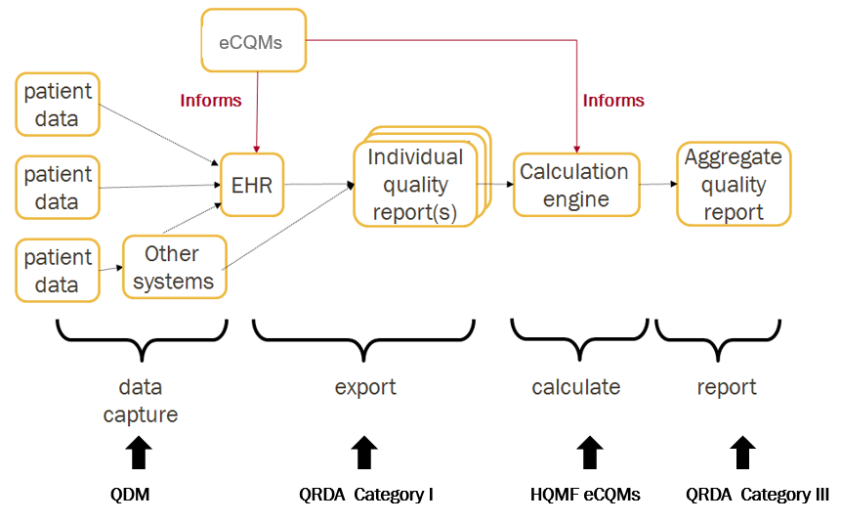

### Relationship to Clinical Quality Language (CQL)

Clinical Quality Language[15], or CQL, is an HL7 cross-paradigm specification that defines a high-level, domain-specific language focused on clinical quality and targeted for use by measure and decision support artifact authors. In addition, the specification describes a machine-readable canonical representation called Expression Logical Model (ELM) targeted at implementations and designed to facilitate sharing and evaluation of clinical knowledge.

This ability to render clinical knowledge in a high-level human-readable form as well as an intermediate-level, platform-independent machine-readable form makes CQL an ideal mechanism for specifying the criteria involved in quality measures.

The QRDA Category III Specification supports summary level quality reporting for quality measures specified using CQL.

## Organization of This Guide

This guide includes a set of CDA templates and prescribes their use within a QRDA document. Two volumes comprise this guide. Volume 1 provides narrative introductory and background material pertinent to this implementation guide, including information on how to understand and use the templates in Volume 2. Volume 2 contains the normative Clinical Document Architecture (CDA) templates for this guide along with lists of all templates, code systems, value sets, and changes from the previous version.

The main chapters in the two volumes are:

Volume 1: Chapter 2. QRDA Category III describes the overall structure of the QRDA Category III report.

Volume 2: Chapter 1. Document defines the top-level structure of the document and the document header constraints that apply to QRDA Category III documents.

Volume 2: Chapter 2. Section defines the section templates in a QRDA Category III document.

Volume 2: Chapter 3. Entry defines the entry templates in a QRDA Category III document.

## Conformance Conventions Used in This Guide

### Templates and Conformance Statements

Conformance statements within this implementation guide are presented as constraints from Trifolia Workbench, a template repository.[16] An algorithm converts constraints recorded in Trifolia to a printable presentation. Each constraint is uniquely identified by an identifier at or near the end of the constraint (e.g., CONF:23-14611). The digits in the conformance number before the hyphen identify which implementation guide the template belongs to and the number after the hyphen is unique to the owning implementation guide. Together, these two numbers uniquely identify each constraint. These identifiers are persistent but not sequential. Conformance numbers in this guide associated with a conformance statement that is carried forward from a previous version of this guide will carry the same conformance number from the previous version. This is true even if the previous conformance statement has been edited. If a conformance statement is entirely new it will have a new conformance number.

Bracketed information following each template title indicates the template type (section, observation, act, procedure, etc.), the object identifier (OID) or uniform resource name (URN), and whether the template is open or closed. The identifier OID is the templateId/@root value; all templateIds have a @root value. Versioned templates also have an @extension value, which is a date identifying the version of this template; such templates are identified by URN and the HL7 version (urn:hl7ii). The URN identifier includes both the @root and @extension value for the templateId (for example, identifier urn:hl7ii:2.16.840.1.113883.10.20.27.1.1:2017-06-01).

Each section and entry template in this guide includes a context table. The "Contained By" column indicates which templates use this template, and if the template is optional or required in the containing template. The "Contains" column indicates any templates that the template uses.

A typical template, as presented in this guide, is shown in the figure. The next sections describe specific aspects of conformance statements—open vs. closed statements, conformance verbs, cardinality, vocabulary conformance, containment relationships, and null flavors.

Figure 2: Constraints Format Example

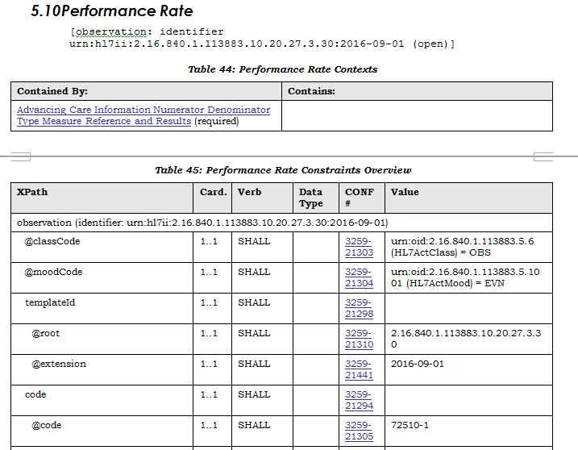

### Template Versioning

A new version of an existing implementation guide reuses templates from the previous version. During the ballot phase or update phase, templates carry the designation “Published” to indicate the template is unchanged from the previous version or “Draft” to indicate a new or revised template. Substantial revisions to previously published templates are indicated by the version number (V2, V3, etc.) in all phases: ballot, update, and published guides.

If there are no substantive changes to a template that has been successfully published, the template will carry the same templateId/@root (identifier oid) and templateId/@extension as in the previous implementation guide. (In the case of older templates, the @extension attribute will not be present.) During a new ballot or update phase, “Published” is appended to the main heading for the template to indicate that the template cannot be commented on in the ballot or update. The “Published” designation is removed in the final publication versions.

A revised version of a previously published template keeps the same templateId/@root as the previous version but is assigned a new templateId/@extension. The notation “(Vn)” (V2, V3, etc.) is also added to the template name. Versions are not necessarily forward or backward compatible. A versioning may be due to substantive changes in the template or because a contained template has changed. The “(Vn)” designation is persistent; it appears with that template when it is used in subsequent guides. During a new ballot or update phase, “Draft” is appended to the main heading for the template to indicate that it may be voted on in the ballot or commented on in the update; the “Draft” designation is removed in the final publication versions.

### Open and Closed Templates

In open templates, all of the features of the CDA R2 base specification are allowed except as constrained by the templates. By contrast, a closed template specifies everything that is allowed and nothing further may be included. Templates in a QRDA Category III document are open.

There are no closed templates in this guide.

Open templates allow HL7 implementers to develop additional structured content not constrained within this guide. HL7 encourages implementers to bring their use cases forward as candidate requirements to be formalized in a subsequent version of the standard to maximize the use of shared semantics.

### Conformance Verbs (Keywords)

The keywords shall, should, may, need not, should not, and shall not in this document are to be interpreted as described in the *HL7 Version 3 Publishing Facilitator's Guide*[17]:

* shall: an absolute requirement for the particular element. Where a SHALL constraint is applied to an XML element, that element must be present in an instance, but may have an exceptional value (i.e., may have a nullFlavor), unless explicitly precluded. Where a SHALL constraint is applied to an XML attribute, that attribute must be present, and must contain a conformant value.
* shall not: an absolute prohibition against inclusion
* should/should not: best practice or recommendation. There may be valid reasons to ignore an item, but the full implications must be understood and carefully weighed before choosing a different course
* may/need not: truly optional; can be included or omitted as the author decides with no implications

The keyword "shall" allows the use of nullFlavor unless the requirement is on an attribute or the use of nullFlavor is explicitly precluded.

When conformance statements are nested (or have subordinate clauses) the conformance statements are to be read and interpreted in hierarchical order. These hierarchical clauses can be interpreted as "if then, else" clauses.

### Cardinality

The cardinality indicator (0..1, 1..1, 1..*, etc.) specifies the allowable occurrences within a document instance. The cardinality indicators are interpreted with the following format “m…n” where m represents the least and n the most:

* 0..1 zero or one
* 1..1 exactly one
* 1..* at least one
* 0..* zero or more
* 1..n at least one and not more than n

When a constraint has subordinate clauses, the scope of the cardinality of the parent constraint must be clear. In the next figure, the constraint says exactly one participant is to be present. The subordinate constraint specifies some additional characteristics of that participant.

Figure 3: Constraints Format – Only One Allowed

1. SHALL contain exactly one [1..1] **participant** (CONF:2777).

a. This participantSHALL contain exactly one [1..1] **@typeCode**="LOC"   
 (CodeSystem: 2.16.840.1.113883.5.90 HL7ParticipationType) (CONF:2230).

In the next figure, the constraint says only one participant “like this” is to be present. Other participant elements are not precluded by this constraint.

Figure 4: Constraints Format – Only One Like This Allowed

1. SHALL contain exactly one [1..1] **participant** (CONF:2777) such that it

a. SHALL contain exactly one [1..1] **@typeCode**="LOC" (CodeSystem:

2.16.840.1.113883.5.90 HL7ParticipationType) (CONF:2230).

### Vocabulary Conformance

The templates in this document use terms from several code systems. These vocabularies are defined in various supporting specifications and may be maintained by other bodies, as is the case for the LOINC® and SNOMED CT® vocabularies.

Note that value set identifiers (e.g., ValueSet 2.16.840.1.113883.1.11.78 Observation Interpretation (HL7) **DYNAMIC**) used in the binding definitions of template conformance statements do not appear in the XML instance of a CDA document. The definition of the template must be referenced to determine or validate the vocabulary conformance requirements of the template.

Value set bindings adhere to HL7 Vocabulary Working Group best practices, and include both an indication of stability and of coding strength for the binding. Value set bindings can be **STATIC**, meaning that they bind to a specified version of a value set, or **DYNAMIC**, meaning that they bind to the most current version of the value set. If a **STATIC** binding is specified, a date **SHALL** be included to indicate the value set version. If a **DYNAMIC** binding is specified, the value set authority and link to the base definition of the value set **SHALL** be included, if available, so implementers can access the current version of the value set. When a vocabulary binding binds to a single code, the stability of the binding is implicitly **STATIC**.

Figure 5: Binding to a Single Code

2. SHALL contain exactly one [1..1] code (CONF:15403).

a) This code SHALL contain exactly one [1..1] @code="11450-4" Problem List

(CONF:15408).

b) This code SHALL contain exactly one [1..1] @codeSystem="2.16.840.1.113883.6.1"

(CodeSystem: LOINC 2.16.840.1.113883.6.1 STATIC) (CONF: 31141).

The notation conveys the actual code (11450-4), the code’s displayName (Problem List), the OID of the codeSystem from which the code is drawn (2.16.840.1.113883.6.1), and the codeSystemName (LOINC).

HL7 Data Types Release 1 requires the codeSystem attribute unless the underlying data type is “Coded Simple” or “CS”, in which case it is prohibited. The displayName and the codeSystemName are optional, but recommended, in all cases.

The above example would be properly expressed as follows.

Figure 6: XML Expression of a Single-code Binding

<code code="11450-4" codeSystem="2.16.840.1.113883.6.1"/>

<!-- or -->

<code code="11450-4" codeSystem="2.16.840.1.113883.6.1"

displayName="Problem List"

codeSystemName="LOINC"/>

A full discussion of the representation of vocabulary is outside the scope of this document; for more information, see the *HL7 Version 3 Interoperability Standards,* Normative Edition 2010[18] sections on Abstract Data Types and XML Data Types R1.

When a template uses value set bindings, value set tables are presented below the template or are referenced if they occur elsewhere in the specification. The value set table provides the value set identifier, a description, and a link to the source of the value set when possible. Ellipses in the last row indicate the value set members shown are examples and the true source must be accessed to see all members.

If a value set binding has a DYNAMIC stability, implementers creating a CDA document must go to the location in the URL to check for the most current version of the value set expansion.

### Null Flavor

Information technology solutions store and manage data, but sometimes data are not available; an item may be unknown, not relevant, or not computable or measureable. In HL7, a *flavor* of null, or nullFlavor, describes the reason for missing data.

Figure 7: nullFlavor Example

<birthTime nullFlavor="NI"/> <!--coding a birthdate when there is no birthdate available-->

Use null flavors for unknown, required, or optional attributes:

* NI No information. This is the most general and default null flavor.
* NA Not applicable. Known to have no proper value (e.g., last menstrual period for a male).
* UNK Unknown. A proper value is applicable, but is not known.
* ASKU Asked, but not known. Information was sought, but not found (e.g., the patient was asked but did not know).
* NAV Temporarily unavailable. The information is not available, but is expected to be available later.
* NASK Not asked. The patient was not asked.
* MSK There is information on this item available but it has not been provided by the sender due to security, privacy, or other reasons. There may be an alternate mechanism for gaining access to this information.
* OTH The actual value is not and will not be assigned a standard coded value. An example is the name or identifier of a clinical trial.

This list above contains those null flavors that are commonly used in clinical documents. For the full list and descriptions, see the nullFlavor vocabulary domain in the CDA normative edition.[19]

Any SHALL, SHOULD or MAYconformance statement may use nullFlavor, unless the nullFlavor is explicitly disallowed (e.g., through another conformance statement which includes a SHALL conformance for a vocabulary binding to the @code attribute, or through an explicit SHALL NOT allow use of nullFlavor conformance).

Figure 8: Attribute Required (nullFlavor Not Allowed)

1. SHALL contain exactly one [1..1] code (CONF:15407).

a. This code SHALL contain exactly one [1..1] @code="11450-4" Problem List   
 (CodeSystem: LOINC 2.16.840.1.113883.6.1) (CONF:15408).

or

2**.** SHALL contain exactly one [1..1] **effectiveTime/@value** (CONF:5256).

Figure 9: Allowed nullFlavors when element is required (with xml examples)

1. SHALL contain at least one [1..*] id

2. SHALL contain exactly one [1..1] code

3. SHALL contain exactly one [1..1] effectiveTime

<entry>

<observation classCode="OBS" moodCode="EVN">

<id nullFlavor="**NI**"/>

<code nullFlavor="**OTH**">

<originalText>New Grading system</originalText>

</code>

<statusCode code="completed"/>

<effectiveTime nullFlavor="**UNK**"/>

<value xsi:type="CD" nullFlavor="OTH">

<originalText>Spiculated mass grade 5</originalText>

</value>

</observation>

</entry>

### Data Types

All data types used in a CDA document are described in the CDA R2 normative edition.16 All attributes of a data type are allowed unless explicitly prohibited by this specification.

## XML Conventions Used in This Guide

### XPath Notation

Instead of the traditional dotted notation used by HL7 to represent RIM classes, this document uses XML Path Language (XPath) notation[20] in conformance statements and elsewhere to identify the Extensible Markup Language (XML) elements and attributes within the CDA document instance to which various constraints are applied. The implicit context of these expressions is the root of the document. This notation provides a mechanism that will be familiar to developers for identifying parts of an XML document.

XPath statements appear in this document in a monospace font.

XPath syntax selects nodes from an XML document using a path containing the context of the node(s). The path is constructed from node names and attribute names (prefixed by an ‘@’) and concatenated with a ‘/’ symbol.

Figure 10: XML Document Example

<author>

<assignedAuthor>

...

<code codeSystem='2.16.840.1.113883.6.96' codeSystemName='SNOMED CT'

code='17561000' displayName='Cardiologist'/>

...

</assignedAuthor>

</author>

In the above example, the code attribute of the code could be selected with the XPath expression in the next figure.

Figure 11: XPath Expression Example

author/assignedAuthor/code/@code

### XML Examples and Sample Documents

Extensible Mark-up Language (XML) examples appear in figures in this document in this monospace font. XML elements (code, assignedAuthor, etc.) and attribute names (SNOMED CT, 17561000, etc.) also appear in this monospace font. Portions of the XML content may be omitted from the content for brevity, marked by an ellipsis (...) as shown in the example below.

Figure 12: ClinicalDocument Example

<ClinicalDocument xmls="urn:h17-org:v3">

...

</ClinicalDocument>

## Contents of the Package

The following files comprise this implementation guide package.

Table 1: Content of the Package

|  |  |  |
| --- | --- | --- |
| Filename | Description | Applicability |
| CDAR2_IG_QRDAIII_R1_N1_2021MAY_VOL1.pdf | Implementation Guide Introductory Material | Normative |
| CDAR2_IG_QRDAIII_R1_N1_2021MAY_VOL2.pdf | Implementation Guide Template Library and Supporting Material | Normative |
| README.txt | Readme file | Informative |

# QRDA Category III

A QRDA Category III report is a summary report that contains aggregated data. Each report contains quality data for a number of patients for one or more quality measures. The particular measures being reported define the data elements and grouping or stratification levels in the report.

## Major Components of a QRDA Category III Document

This section serves as a high-level introduction to the major components of a QRDA Category III document, all of which are described again and in greater detail later in this document. The intent here is to familiarize the reader with the high-level concepts in order to understand the sections and templates below.

Major components of a QRDA Category III document are shown in the following skeletal example. Note that many required components are missing to simplify the example.

A QRDA Category III document is wrapped by the <ClinicalDocument> element, and contains a header and a body. The header lies between the <ClinicalDocument> and the <structuredBody> elements, and identifies and classifies the document and provides information on authorship, authentication, involved providers, and more.

The body contains the clinical report, which is wrapped by the <structuredBody> element, and which is divided up into document sections.

Three sections are defined: The QRDA Category III Measure Section, which references the measures being reporting and reports associated aggregate scores (both observed and predicted); the Improvement Activity Section, which references the Improvement Activities being reported and reports the responses (e.g., yes); and the Promoting Interoperability Measure Section, which references the promoting interoperability measures being reported and reports associated aggregated counts or the responses.

Each of the QRDA Category III Measure Section, Improvement Activity Section, and the Promoting Interoperability Measure Section contains a required Reporting Parameters Act.

A QRDA Category III document must contain a Measure Section, an Improvement Activity Section, or a Promoting Interoperability Measure section.

Each section contains a single narrative block, and various CDA entries. Entries in the QRDA Category III Measure Section represent all reported data for each referenced measure. The total number of patients in each population (both observed and, optionally, predicted) is reported, along with a breakdown of those numbers by strata and, for proportion measures, both the overall performance rate and reporting rate. Continuous variable values (both observed and predicted) can also be reported.

Figure 13: Skeletal QRDA Category III Document

<ClinicalDocument>

<!--... CDA Header ...-->

<structuredBody>

<section>

<!--QRDA Category III Measure Section -->

<!-- Measure Reference and Results template -->

<organizer>eCQM 0436: Anticoagulation Therapy for A Fib

<!-- Performance Rate for Proportion Measure template -->

<observation>Performance Rate: 83% (62% predicted)</observation>

<!-- Measure Data template -->

<observation>Initial Patient Population

<!-- Aggregate Count template -->

<observation>Count = 1000</observation>

</observation>

<!-- Measure Data template -->

<observation>Numerator

<!-- Aggregate Count template -->

<observation>Count = 400 (300 predicted)</observation>

</observation>

...

</organizer>

</section>

<section>

<!-- Improvement Activity Section -->

...

</section>

<section>

<!-- Promoting Interoperability Measure Section -->

...

</section>

</structuredBody>

</ClinicalDocument>

The image below is a partial rendering of a QRDA Category III sample document. Please compare with the above QRDA skeletal XML example to understand the structure and content of the QRDA Category III report that are described again and in greater detail later in this document.

Figure 14: QRDA Rendering

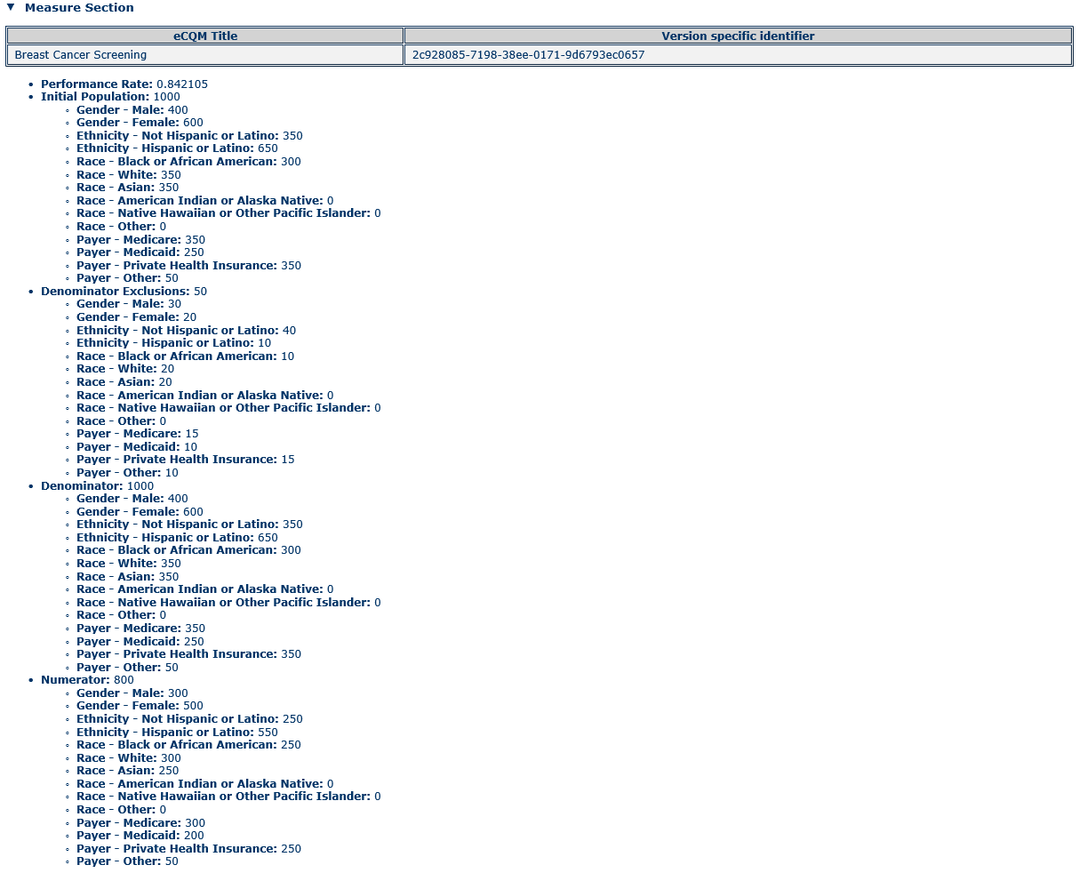

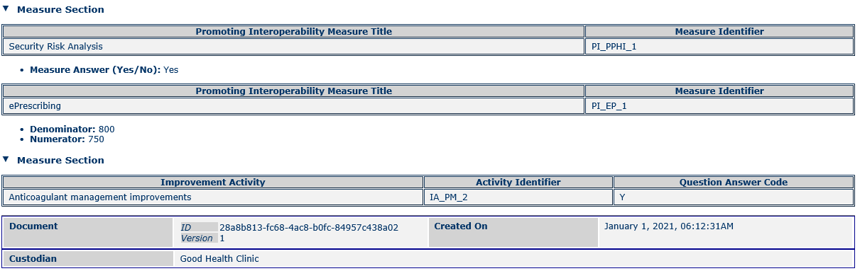

(Note: A QRDA Category III report shall contain at least a QRDA Category III Measure Section, an Improvement Activity Section, or a Promoting Interoperability Measure Section.)

## Report Format

The QRDA Category III report format matches the QRDA Category I report as closely as possible. The Category III header is similar to the Category I header, but the QRDA Category III header does not conform to the US Realm header. This is mainly because the US Realm Consolidation[21] documents require recordTarget elements to contain address and name elements. The recordTarget element is designed for single patient data and is required in all CDA documents. In this case, the document does not contain results for a single patient, but rather for groups of patients, and thus the recordTarget ID in QRDA Category III documents contains a nullFlavor attribute (is nulled). By not conforming to the Consolidation US Realm header, the QRDA Category III documents can omit the recordTarget’s name and address sub-elements, rather than having to set them, along with the recordTarget ID, to null.

The QRDA Category III header is followed by a structured body that contains a reporting parameters section and may contain a QRDA Category III Measure Section, Improvement Activity section, or a Promoting Interoperability Measure Section. Depending on the program or individual organization’s reporting requirement, at least a QRDA Category III Measure Section, or an Improvement Activity section, or a Promoting Interoperability Measure Section needs to be included in addition to the reporting parameters section. The QRDA Category III Measure Section contains the references and data for one or more eCQMs. These references refer to the identifiers in the corresponding HQMF document, which can be a published NQF or CMS eCQM or a query. Promoting Interoperability Measure Section contains references (promoting interoperability measure identifiers) and data for one or more promoting interoperability measures. Improvement Activity Section contains references (improvement activity identifiers) and data for one or more improvement activities. There is no patient data section as there is in a QRDA Category I document because there are no raw patient data.

The data are reported in aggregate form, with no reference to any patient identifiers. The data can be reported according to strata that are identified in the corresponding HQMF document; in this case the QRDA report uses the HQMF strata identifiers to refer to the correct stratum definition. The data can further be stratified according to the optional supplemental data elements payer, sex, race, and ethnicity.

To ensure all data are consistently reported, all populations identified in an eCQM should be reported, even when the number of patients in that population is zero. Likewise, all stratifications identified in an eCQM should be reported, even when the number of patients in a stratum is zero, except for populations where the total count is zero. For the optional supplemental data elements, it is sufficient to report non-zero data, leaving out counts that are zero.

For programs that require Performance Rate for Proportion Measure in a QRDA Category III report, all Performance Rates called for in the eCQM should be reported. Performance Rate for Proportion Measure is defined as (Numerator – Numerator Exclusions) / (Denominator – Denominator Exclusions – Denominator Exceptions). Where there are patients in the Denominator but none in the Numerator, the Performance Rate is zero. Where there are no patients in the Denominator (and therefore no patients in the Denominator Exclusions, Denominator Exceptions, and Numerator populations), the Performance Rate is null (using a nullFlavor of “NA”).

Many of the conformance rules in this guide are recommended and optional. Organizations receiving reports may choose to define their own implementation guides, based on this one, that require data defined as recommended (SHOULD) or optional (may). They may also choose to place other requirements and constraints on the reporting institutions.

## Organizational Roles

Organizational roles in QRDA Category III are defined as in QRDA Category I, where several CDA Header participations can be played by the same person. In such cases, the person should be identified as the player for each appropriate participation. For instance, if a person is both the author and the legal authenticator of a document, the CDA Header should identify that person as both the author participant and the legal authenticator participant.

On other occasions, CDA Header participants are played by different people. The following table shows a number of scenarios and the appropriate values for various participants. Where a QRDA Category III report is created by a registry or other intermediary, the author is the registry, whereas the organization that owns and reports the data to the registry is the custodian.

Table 2: Header Participant Scenarios

|  |  |  |  |
| --- | --- | --- | --- |
| Scenario | Author | Custodian | Legal Authenticator |
| QRDA is wholly constructed automatically by device | Device | Organization that owns and reports the data (e.g., hospital) | A designated person in the organization (may be assigned to the report automatically) |
| QRDA is partially constructed automatically by device, partially constructed by quality manager | Device;  Quality Manager | Organization that owns and reports the data (e.g., hospital) | A designated person in the organization (such as the Quality Manager) |
| QRDA is constructed manually (e.g., by an organization that doesn’t have an EHR) | Quality Manager | Organization that owns and reports the data (e.g., hospital) | A designated person in the organization (such as the Quality Manager) |
| QRDA is constructed by a registry or other intermediary | Registry device or person | Organization that owns and reports the data to the registry (e.g., hospital) | A designated person in the registry |

The following table shows two header relationship scenarios in QRDA CATEGORY III and the appropriate values.

Table 3: Header Relationship Scenarios

|  |  |  |
| --- | --- | --- |
| Scenario | DocumentationOf/ServiceEvent | AuthorizationOf/Consent |
| QRDA is wholly constructed by a registry | Captures the detail of the providers at the care providing institutions | Indicates the eligible professional has given the data submission vendor registry permission to submit data on their behalf |
| QRDA is wholly constructed by a provider/provider system | Captures the detail of the providers at the care providing institutions | Not Applicable |

# References

* *Clinical Quality Language,* <https://cql.hl7.org/>
* *HL7 CDA R2 Implementation Guide: Quality Reporting Document Architecture – Category I, US Realm.* [*http://www.hl7.org/implement/standards/product_brief.cfm?product_id=35*](http://www.hl7.org/implement/standards/product_brief.cfm?product_id=35)
* *HL7 Clinical Document Architecture (CDA Release 2)*. <http://www.hl7.org/implement/standards/product_brief.cfm?product_id=7>
* *HL7 Implementation Guide for CDA Release 2.1: Consolidated CDA Templates for Clinical Notes (US Realm), August*, 2015, with subsequent errata. <http://www.hl7.org/implement/standards/product_brief.cfm?product_id=492>
* *HL7 Version 3 Interoperability Standards, Normative Edition 2010*. <http://www.hl7.org/memonly/downloads/v3edition.cfm#V32010>
* *HL7 Version 3 Publishing Facilitator's Guide.* <http://www.hl7.org/v3ballot/html/help/pfg/pfg.htm>
* *HL7 Version 3 Standard: Refinement, Constraint and Localization, Release 2.* <http://www.hl7.org/v3ballot/html/infrastructure/conformance/conformance.htm>
* *HL7 Version 3 Standard: Representation of the Health Quality Measures Format (eMeasure), Release 1* [*h*ttp://www.hl7.org/implement/standards/product_brief.cfm?product_id=97](http://www.hl7.org/implement/standards/product_brief.cfm?product_id=97)
* *Institute of Medicine (US) Committee on Quality of Health Care in America. Crossing the Quality Chasm: A New Health System for the 21st Century. Washington (DC): National Academies Press (US); 2001.* <https://pubmed.ncbi.nlm.nih.gov/25057539/>.
* *Improvement Activities.* <https://qpp.cms.gov/mips/improvement-activities>
* *Promoting Interoperability Measures.* <https://qpp.cms.gov/mips/promoting-interoperability>
* *Measure Authoring Tool.* <https://www.emeasuretool.cms.gov/>
* *Medicare Program; Merit-Based Incentive Payment System (MIPS) and Alternative Payment Model (APM) Incentive Under the Physician Fee Schedule, and Criteria for Physician-Focused Payment Models.* <https://www.federalregister.gov/documents/2016/11/04/2016-25240/medicare-program-merit-based-incentive-payment-system-mips-and-alternative-payment-model-apm>
* *The Quality Data Model (QDM).* <https://ecqi.healthit.gov/qdm>
* *Trifolia Workbench*. [http://trifolia.lantanagroup.com](http://trifolia.lantanagroup.com/)
* *XML Path Language (XPath) Version 1.0.* <http://www.w3.org/TR/xpath/>

1. Acronyms and Abbreviations

CCN CMS Certification Number

CDA Clinical Document Architecture

C-CDA Consolidated CDA

CDA R2 CDA Release 2

CDC Centers for Disease Control and Prevention

CMS Centers for Medicare & Medicaid Services

CQM Clinical Quality Measure

DENOM Denominator

DSTU Draft Standard for Trial Use

EHR Electronic Health Record

HHS US Department of Health and Human Services

HL7 Health Level Seven

HQMF Health Quality Measures Format

IG Implementation Guide

IHTSDO International Health Terminology Standard Development Organization

IOM Institute of Medicine

IPOP Initial Population

LOINC Logical Observation Identifiers Names and Codes

MACRA Medicare Access and CHIP Reauthorization Act of 2015

MAT The Measure Authoring Tool

MIPS Merit-based Incentive Payment System

NPI National Provider Identification

NQF National Quality Forum

NUMER Numerator

OID Object identifier

ONC Office of the National Coordinator, HHS

QRDA Quality Reporting Document Architecture

RIM Reference Information Model

SNOMED CT Systematized Nomenclature of Medicine, Clinical Terms

STU Standard for Trial Use

TIN Tax Identification Number

UCUM Unified Code for Units of Measure

XML Extensible Mark-up Language

XPath XML Path Language

1. Institute of Medicine (US) Committee on Quality of Health Care in America. Crossing the Quality Chasm: A New Health System for the 21st Century. Washington (DC): National Academies Press (US); 2001. <https://pubmed.ncbi.nlm.nih.gov/25057539/>.
2. HL7 Implementation Guide for CDA Release 2 – Consolidated CDA Templates for Clinical Notes. August, 2015, with subsequent errata. <http://www.hl7.org/implement/standards/product_brief.cfm?product_id=492>
3. HL7 CDA R2 Implementation Guide: Quality Reporting Document Architecture – Category I, US Realm, product page. http://www.hl7.org/implement/standards/product_brief.cfm?product_id=35
4. The Quality Data Model (QDM). <https://ecqi.healthit.gov/qdm>
5. HL7 Quality Reporting Document Architecture (QRDA III), Release 1 – US Realm. <http://www.hl7.org/implement/standards/product_brief.cfm?product_id=286>
6. Improvement Activities. <https://qpp.cms.gov/mips/improvement-activities>
7. Promoting Interoperability Measures. <https://qpp.cms.gov/mips/promoting-interoperability>
8. HIT: Standards, Implementation Specifications, and Certification Criteria for EHR Technology, 2014 Edition. <http://www.gpo.gov/fdsys/pkg/FR-2012-09-04/pdf/2012-20982.pdf>
9. Medicare Program; Merit-Based Incentive Payment System (MIPS) and Alternative Payment Model (APM) Incentive Under the Physician Fee Schedule, and Criteria for Physician-Focused Payment Models. <https://www.federalregister.gov/documents/2016/11/04/2016-25240/medicare-program-merit-based-incentive-payment-system-mips-and-alternative-payment-model-apm>
10. HL7 QRDA Category III STU Release 2 STU Comment page. <http://www.hl7.org/dstucomments/showdetail.cfm?dstuid=197>
11. HL7 Version Standard: Refinement, Constraint, and Localization, Release 2. <http://www.hl7.org/v3ballot/html/infrastructure/conformance/conformance.htm>
12. HL7 CDA Release 2. http://www.hl7.org/implement/standards/product_brief.cfm?product_id=7
13. HL7 Version 3 Standard: Representation of the Health Quality Measures Format (eMeasure), Release 1. <http://www.hl7.org/implement/standards/product_brief.cfm?product_id=97>
14. Measure Authoring Tool. <https://www.emeasuretool.cms.gov/>
15. Clinical Quality Language, <https://cql.hl7.org/>
16. Trifolia Workbench. <https://trifolia.lantanagroup.com/>
17. HL7 Version 3 Publishing Facilitator's Guide. <http://www.hl7.org/v3ballot/html/help/pfg/pfg.htm>
18. *HL7 Version 3 Interoperability Standards, Normative Edition, 2010.* <http://www.hl7.org/memonly/downloads/v3edition.cfm#V32010>
19. *HL7 CDA Release 2*. <http://www.hl7.org/implement/standards/product_brief.cfm?product_id=7>
20. XML Path Language (XPath) Version 1.0. <http://www.w3.org/TR/xpath/>
21. HL7, Consolidated CDA. <http://www.hl7.org/implement/standards/product_brief.cfm?product_id=258>